When Is The Rapture? Signs Are Everywhere??
April 7, 2017
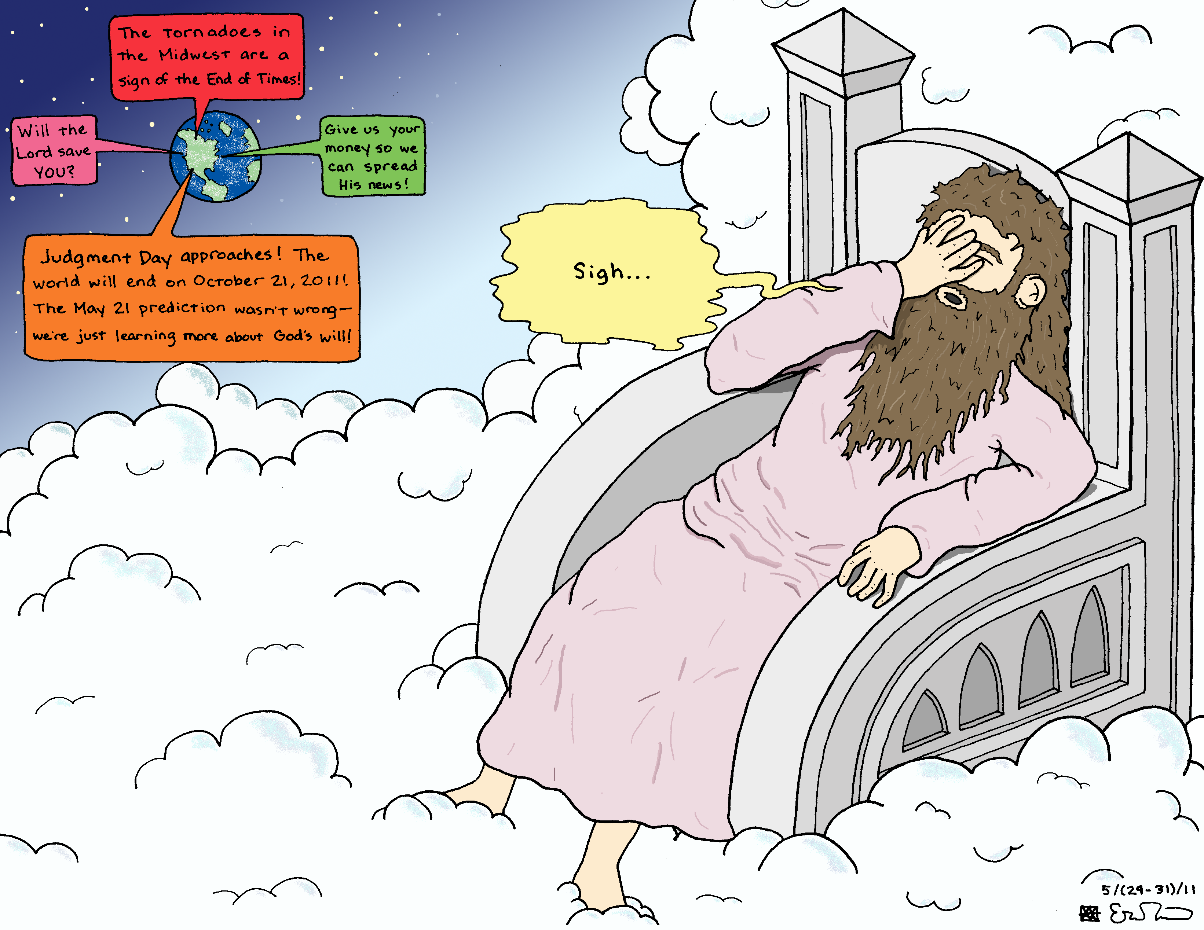
May we not lean on our own understanding, Heartdwellers, but trust the Lord and follow His instructions to us.

I am praying this prayer, because it seems like every time I turn around there’s another urgent Rapture warning. They have been so frequent it has made me feel unsettled. I do not go looking for these, they end up in my inbox from various sources.

So, after hours of worship, I asked the Lord.

Lord, I am troubled about these Rapture warnings. You are not addressing that with Me or with the Heartdwellers. Am I missing something?

Jesus began, "How many years have you heard that the Rapture would be next month or six months from now? How many years?"

Uhh.... At least two and a half.

"That’s correct. And has it happened yet?"

Not that I know of.

"That, too, is correct. Clare, My precious one, it takes a very long time to bring about change in a soul. Look at yourself, for example. How many years ago did you first understand that the Rapture was coming and you were not prepared?"

Ummm...I’m not sure. Seven?

"Nine."

Oh.

"For nine years I have been preparing you and you still have a ways to go. It is My Mercy that is holding the Rapture back while moving on the hearts of men to understand that they are not ready and they need to be NOW.”

As He was speaking, this Scripture came to mind, The Lord is not slow to fulfill His promise as some understand slowness, but is patient with you, not wanting anyone to perish, but everyone to come to repentance. 2 Peter 3:9

"I’m not saying you won’t be taken." Jesus continued. "That’s your decision. You know what would disqualify you. As long as you hold to the right way, you are safe to assume you will be taken.

"If you are deliberately in disobedience and rebellion and turn from the right way to follow your own will, you will be left behind.

"Right now it is looking good for you, but guard your ways, My Bride; the enemy is clever and has his sights on you. And not just you, but all ministers. The sheep follow the shepherd and if the enemy can mislead you, the flock will follow. This is why ministers and their children are big targets.

"However, you are loving Me and wanting to love Me more by your actions and will, and this is the safest place for you and the flock to be.

"But to answer your question directly, it takes a long time to turn a man’s will from the world to Me. And if they heed the warnings now, they may indeed be ready. That is why these warnings are still being sent out. And as we discussed, have been in your life, shaping your behavior for nine years.

"My people, if you are living for yourself, you are at high risk of being left behind. If you are living for Me and obedient to My known will, you are safe and will be taken. It’s just that simple. Examine your hearts and your life for fruit. Examine your motives. Get to the bottom of why you do what you do. If it is done out of any other motive than love for Me and your brother, you are at risk and need to abandon those ways.

"Well, Clare, tonight you asked about something to add humidity to the air to help your voice and I told you 'no.' In fact, because you have stubbornly latched onto this idea, I gave you Pride. (A reading from the Bible Promise Book) Whenever you get it in your head that you need something and I tell you 'no,' if you yield as you did tonight when you prayed to Me before hand, 'Lord, please help me to accept your will graciously and with trust that You know what is best.' When you do that, your heart is on the right track.

"But when you resist and insist, you are strongly set in self-will, Pride and your own understanding, which is SO limited, it is laughable. So, always accept My answer, My will with gracious acquiescence that I know what is best. And to have what I do not want you to have is not only unnecessary, but leads you deeper into pride and self-will. That is the wrong direction. That is the 'left behind' direction. So, continue to climb the ladder of self-denial, self-forgetfulness and brotherly love, and you will be ready."

Lord, could I check out what Kim Clement said about Trump’s term in office?

"No. I want you to trust what I have told you and not seek confirmations from others."

But Lord, You said out of the mouths of two or three….

"You are a clever one. If you check him out, you will seek others and that will lead to confusion. I have marked out a child-like path for you. If you stay focused on that, all will go well and you will not be a hypocrite, telling others not to check things out while you do.

"When I ask you not to, it’s because it isn’t healthy for you. Not one prophet has it all totally right. Some are close; others far away from truth. Yet I have marked out a safe path for you, that if you follow it in childlike faith, you and your flock will arrive safely at your destination.

"I am avoiding spiritual indigestion. Building a useful life while fighting the enemy does not need to be compromised by radical swings from right to left and left to right, by conflicting reports from conflicting prophets. …a double-minded man, unstable in all his ways. James 1:8

"I have mapped out the safe way. Stay on this path and you will have much more energy for creating and much less confusion and opportunity for the demons to sift you, because you disobeyed and got curious.”

And here what came to mind was the Scripture, "Truly I tell you", He said, “unless you change and become like little children, you will never enter the kingdom of heaven. Matthew 18:3

Jesus continued, "A baby on a journey with her parents doesn’t continually ask questions about where they are going and when they will get there. She sits in the car and enjoys the ride and the scenery. She doesn’t worry because she is in the safe-keeping of her parents.

"This is the heart attitude you must have. Trust and refuse to worry or be swayed by conflicting reports. I explained to you why I am sending out these urgent warnings. Trust Me, My Love. Trust Me with all your heart and never lean on your own understanding. Acknowledge My wisdom and guidance in all you do, and you will easily, simply, without stress, follow the path I have mapped out for you.”

And that comes from Proverbs 3:5

I have made your paths straight. Look neither to the right nor the left, but continue on the narrow way of My choosing and My wisdom. Matthew 7:13

"Be secure in this, My dear one, be secure. It is the sure way to prepare you for the Rapture and bring forth much wonderful fruit at the same time.

"I believe in you Clare. Believe in Me, too.

"Come here, let Me cradle you in My arms. You are so precious to Me. I will never, ever mislead you. Ever. If there is something you need to know, I will tell you. If I do not bring it up, it is not relevant in your life. Be at Peace. Be at Peace."

And that was the end of His message. Just before He gave me this message, I had gotten two rhemas, and I wasn't sure what they meant. But they definitely apply to this situation.

"A soul who trusts in the Lord and places all its hope in Him has nothing to fear. The enemy of our salvation is always around to snatch from our hearts the anchor that is to lead us to salvation, by which I mean, trust in God our Father. Let us keep a firm hold on this anchor and not relinquish it for a single moment."

I don’t know about you, guys, but I hate having fear looming over my shoulder, and that’s what all these mixed messages cause in me. Here’s the other Rhema. Another good one for repentance.

"Sorrow born of self-love is full of anxiety and bitterness. Far from healing our soul’s wounds, it serves only to pour poison over them. But sorrow springing from love of God is serene and full of abandonment to His perfect will."

And I just want to add here, dear ones, I would prefer that, on our channel, you don't leave links to other videos about the Rapture happening this time or the Rapture happening that time, or this dream or that dream. Because it only causes contradiction and confusion. We're trying to lead everyone in a peaceful path. This is what the Lord marked out for us. Not the path of constant anxiety and curiosity. And you have free will, so you can do whatever you choose to do with your time. But for me, I'm tired of it. I'm going to stick to what the Lord has told us. Apply myself to my gifts, so that I have something to share with you. Without all these distractions!

And I would ask my prayer warriors to please consider this message very seriously. And please don't send things to my inbox that are full of excitement about the next Rapture dream or the Rapture vision, or such and such happening here, or such and such is happening there. It's just...it just causes anxiety. And I'm weak. I don't have a lot of self-control. So, if I see something like that, my curiosity will get the better part of me and I'll end up wasting time.

And you know, if I get on the internet to look up one thing, in the margins there's all these other things that support that one thing. And I end up going on a wild juice...lol. I end up going on a wild 'juice' chase. I end up going on a wild goose chase.

So please, dear ones. Don't post those things in my inbox. Please do not post them on our channel. Let's pay attention to what the Lord is saying and really dedicate ourselves to prayer and our apostolate, the thing that He's given us to do.

The Lord bless you, Heartdwellers. And I want to thank those of you who have been supporting us. It really helps tremendously. It makes everything work smoothly. As a result of that, I was able to help 8 different people with uh, very poor families. It's Cold here in the mountains. We were able to get wood for them, and we're able to get images of the Lord printed up that we can share with you and send out.

So, thank you so much for helping and supporting. This is our whole means of income. We really appreciate it, and all we want to do is grow and expand and do more for each of you. So, it's greatly appreciated.

The Lord bless you all. Please, let's take this message to heart. Please?

